The Reprot


Course Code | : | SCST1223
Course Name | : | PROBABILITY AND STATISTICAL DATA ANALYSIS
Lecturer | : | SHAMINI A/P RAJA KUMARAN
Academic Session | : | 2025-2026/2
Assessment Title | : | Project Proposal Report (Phase 1)
Submission Due Date | : | Wednesday, 8 April 2026, 5:00 PM
Prepared by | : | Matric No. | Student Name
 |  | A23CS4026 | Mohammed Mohsen Mohammed Alsakkaf
 |  | A25CS4079 | Youssef Elsayed Abdelrazek Mahmoud Harraz
 |  | A25CS4065 | Qusai Mahmoud Ali Hijazi
 |  | A25CS4074 | Guo Siqi
 |  | A25CS4076 | Mohammed Esam
Assessment Mode: |  | Group Project
Feedback from Lecturer :
Student Declaration

I hereby declare that this assessment is my own original work. I have not plagiarised any sources and have not used generative AI tools unless explicitly permitted by the lecturer. All references used have been properly acknowledged.

Signatures:

Table of Content

1. Introduction 3
1.1. Purpose of the Study: 3
1.2. Problem Statement: 3
1.3. Scope of Study: 3
2. Data Collection 4
2.1. Population and Sampling: 4
2.2. Method of Collection: 4
2.3. Variables and Levels of Measurement: 4
3. Data Analysis 5
3.1. Categorical Data Analysis: 5
3.1.1. Graphs: 5
3.1.2. Numerical: . 5
3.1.3. Frequency Distributions: 5
3.2. Quantitative Data Analysis: 6
3.2.1. Graphs: 6
3.2.2. Numerical Data Visualization: 6
3.2.3. Measures of Central Tendency: 6
3.2.4. Measures of Dispersion: 7
4. Conclusion 7
4.1. Summary of Findings: 7
4.2. Learning Reflections: 7
5. References 8
6. Appendix 9

Introduction
Caffeine is one of the most widely consumed psy1choactive substances among university students. As undergraduates at Universiti Teknologi Malaysia (UTM) face demanding academic schedules, many turn to caffeinated beverages to maintain alertness. This study falls under the healthcare scope, focusing on how these habits affect the physical well-being of the student population.
As students in Section 01, we often see our peers staying up late with coffee in the library, and we were curious to see if this habit actually helps their focus or just ruins their sleep.

Purpose of the Study:
The primary purpose of this study is to provide a descriptive analysis of caffeine consumption patterns among UTM undergraduate students. Specifically, we aim to understand the relationship between daily caffeine intake and its perceived impact on sleep quality and academic focus levels.

Problem Statement:
While caffeine is used to enhance short-term focus, its long-term impact on healthcare—specifically sleep hygiene is often overlooked by students. There is a concern that excessive reliance on caffeine to manage academic workloads leads to a negative cycle of poor sleep and reduced natural cognitive focus. We expect to see that while students report improved immediate focus, their overall sleep quality scores will show a declining trend.

Scope of Study:
This study is restricted to the undergraduate population of Universiti Teknologi Malaysia (UTM) Johor Bahru. We are targeting students across all faculties (Computing, Engineering, Science, etc.) to ensure a diverse healthcare profile of the student body.

Data Collection

Population and Sampling:
The population for this study consists of all undergraduate students currently enrolled at UTM. For our sample, we are using convenience sampling to gather a minimum of 60 respondents. This sample size was chosen to meet the minimum requirements of the Project Phase 1 and to ensure statistical significance for our descriptive analysis.

Method of Collection:
Data was gathered through primary collection using a structured digital questionnaire (Google Forms). The survey link was distributed via university social media channels, primarily WhatsApp and Telegram student groups, to reach various faculty demographics within the specified deadline.

Variables and Levels of Measurement:
No | Variable Name | Level of Measurement | Description
1 | Gender / Faculty | Nominal | Categorical labels for demographic groups.
2 | Caffeine Choice | Nominal | Preference (Coffee, Tea, Energy drinks).
3 | Sleep Impact Score | Ordinal | Likert scale rating from Negatively to Positively.
4 | Addiction Level | Ordinal | Rated from 1 (Low) to 5 (High).
5 | Focus Levels | Interval | Scale of 1 to 10 for current focus status.
6 | Effect Duration | Ratio | The number of hours of caffeine remains effective.
7 | Cups per Day | Ratio | Number of drinks consumed (Numeric input).

Data Analysis
Note: All analysis in this section must be performed using R programming

Categorical Data Analysis:

Graphs:

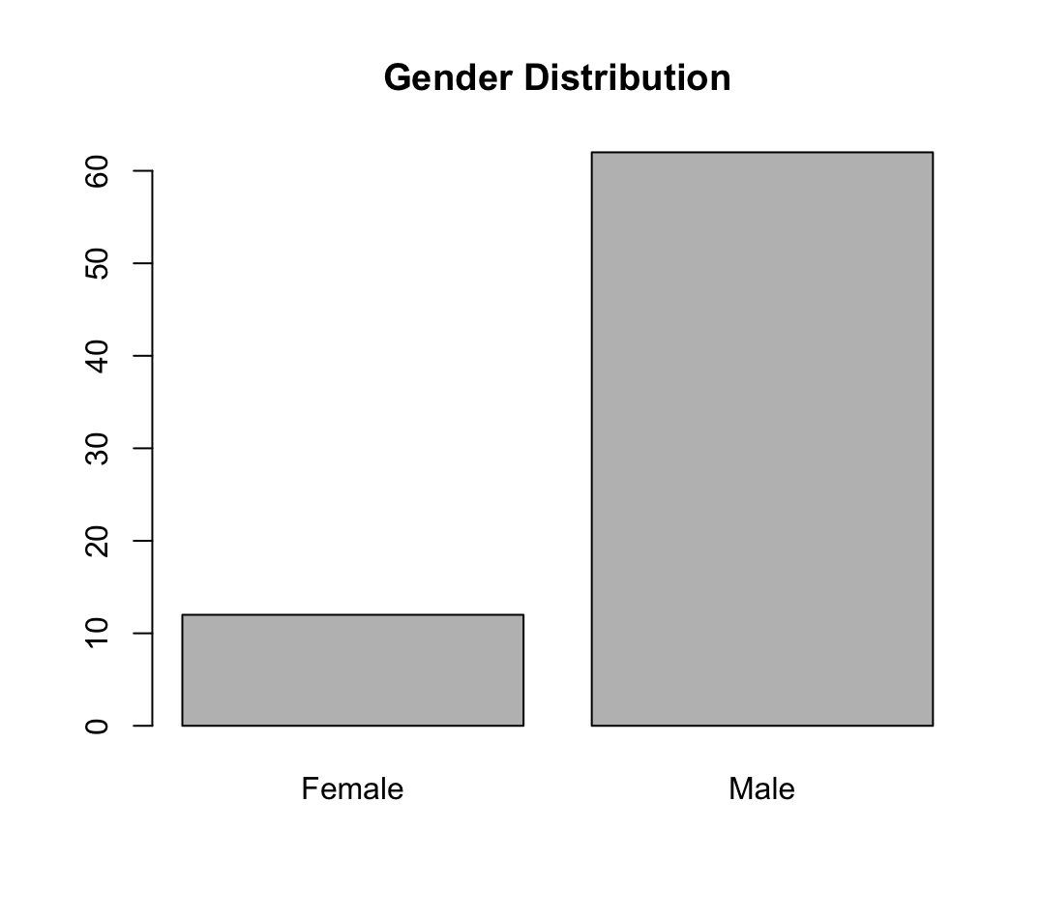
Figure 3.1
urveyed UTM student population, with 74.3% of respondents reporting regular intake. The data shows that Coffee-based drinks are the most popular choice at 47.3%, followed by tea. While students reported a median focus level of 7 out of 10 after consumption, the right-skewed distribution of daily cups indicates that while most drink 1–2 cups, a minority consumes significantly higher amounts. All statistical analyses and visualizations were performed using R programming to ensure data accurac
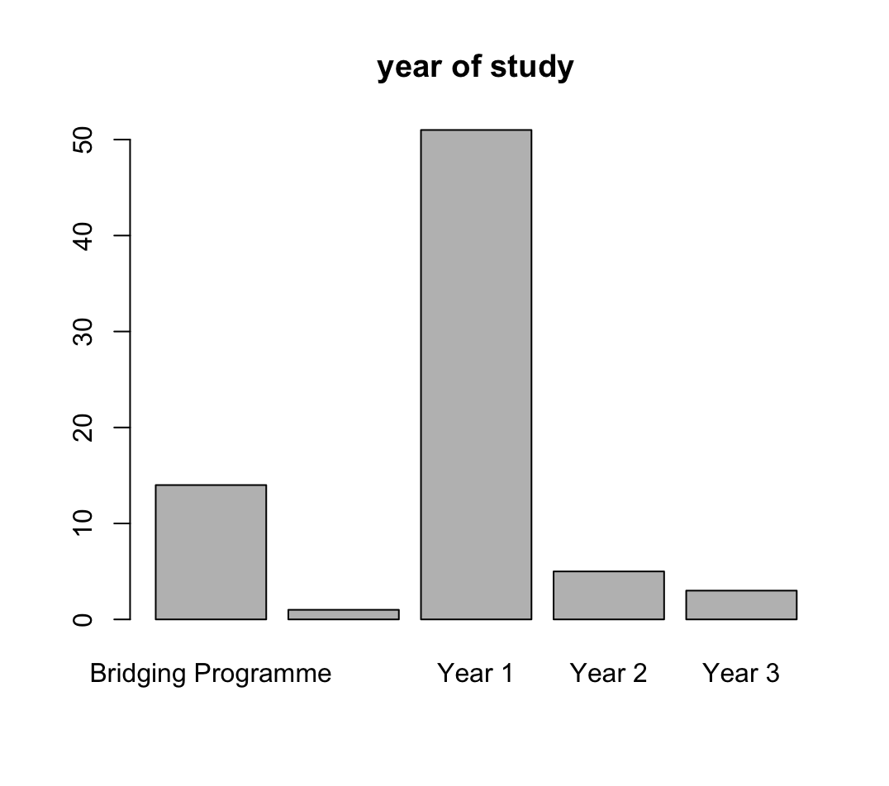

Figure 3.1‏
‏Figure 3.1 presents a bar chart illustrating the academic level distribution of the 74 participants involved in the study. It is evident that the vast majority of respondents are Year 1 students, with the count exceeding 50 individuals, which aligns with the recent intake data. This is followed by students in the Bridging Programme, while Year 2, Year 3, and Final Year students represent a significantly smaller portion of the total sample. This distribution indicates that the primary data collected reflects the perspectives and habits of students in the early stages of their university education

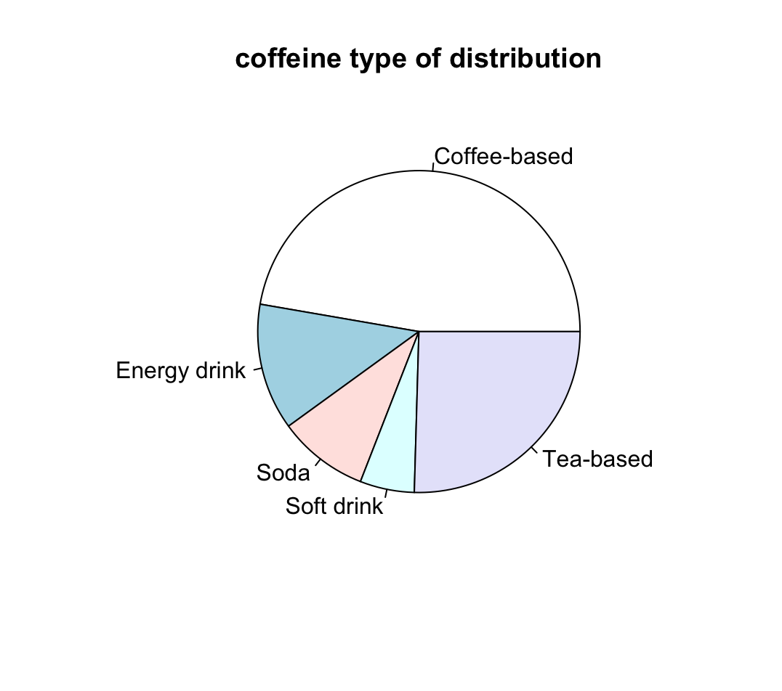
Figure 3.1
‏Figure 3.2 illustrates the preferences of respondents regarding different types of caffeinated beverages. The pie chart clearly shows that Coffee-based drinks are the most dominant category, accounting for nearly half of the total preferences at 47.3% (26 students). Tea-based drinks represent the second-largest portion at 25.5% (14 students). Other categories, including Energy drinks (12.7%), Soda (9.1%), and Soft drinks (5.5%), make up the remainder of the distribution. This visual representation emphasizes that traditional beverages like coffee and tea are the primary sources of caffeine for the majority of the surveyed students

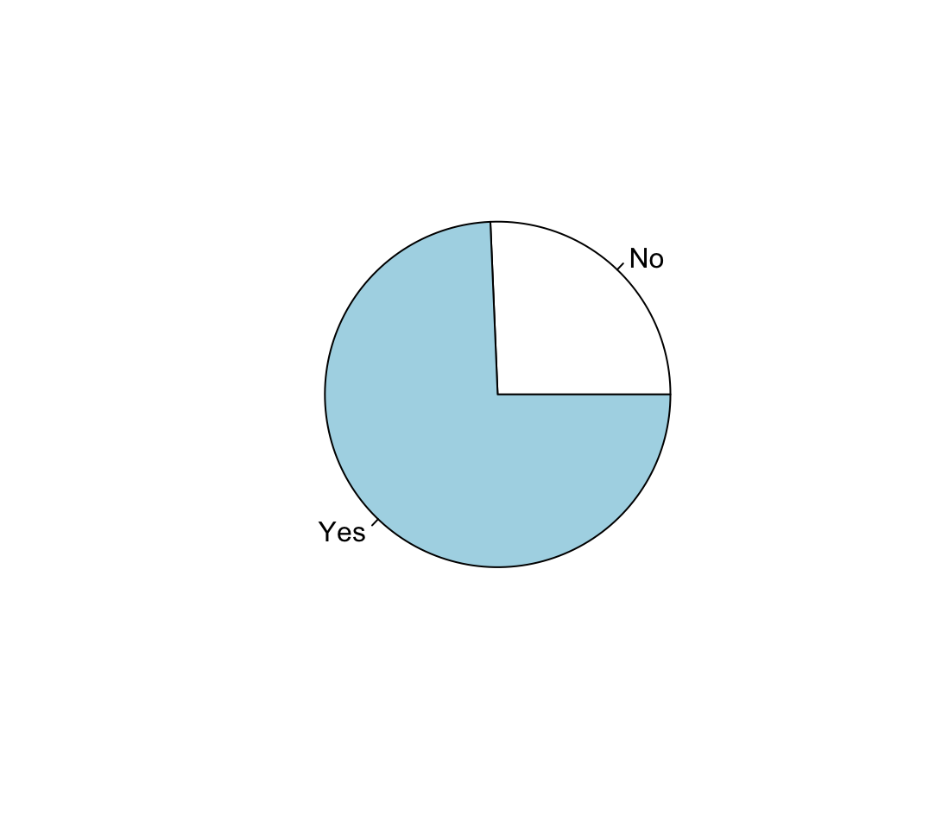
Figure 3.1
presents the proportion of students who regularly consume caffeine compared to those who do not. The pie chart indicates that a significant majority of the participants (74.3% or 55 students) answered 'Yes', confirming their regular intake of caffeinated beverages. Conversely, a smaller segment of the sample (25.7% or 19 students) responded with 'No'. This high percentage of consumption suggests that caffeine is a common element in the daily lives of the majority of students surveyed in this study.

Numerical:
The year of study :

Year of study | N | percentage
Bridging programme | 14 | 18.918919%
year1 | 51 | 68.918919 %
year2 | 5 | 6.756757%
year3 | 3 | 4.054054%
year4 | 1 | 1.351351%
Total | 74 | 1000

Caffeine type of distribution:

Caffeine type | N | percentage
Coffee-based | 26 | 47.3%
Energy drink | 7 | 12.7%
Soda | 5 | 9.1%
Soft drink | 3 | 5.5%
Tea-based | 14 | 25.5%
Total | 55 | 100%

The gender of the student:

Gender | N | Percentage
Male | 62 | 83.78378%
Female | 16 | 16.21622%
Total | 74 | 100%

The number of students who consume caffeine :

Answer | N | Percentage
Yes | 55 | 74.32432 %
No | 19 | 25.67568
Total | 74 | 100%

3.1.3Frequency Distributions:

Gender:
Female Male Female Male
12 62 16.21622% 83.78378%

The frequency table for gender shows that the vast majority of respondents are Male, accounting for 83.8% (62 students), while Female respondents represent 16.2% (12 students) of the total sample size.
_____________
Year of study:
Bridging Programme Final Year (Year 4+) Year 1
14 1 51
Year 2 Year 3
5 3

Bridging Programme Final Year (Year 4+) Year 1
18.918919% 1.351351% 68.918919 %
Year 2 Year 3
6.756757% 4.054054%
According to the data, Year 1 students form the largest group in this study with 68.9% (51 students). This is followed by students in the Bridging Programme at 18.9%, while other years combined represent the remaining minority of the sample.
______________

Caffeine type:

Coffee-based Energy drink Soda Soft drink Tea-based
26 7 5 3 14

Coffee-based Energy drink Soda Soft drink Tea-based
47.3% 12.7% 9.1% 5.5% 25.5%

In terms of preferences, Coffee-based drinks are the most popular choice among students, chosen by 47.3% (26 respondents). Tea-based drinks come in second at 25.5%, indicating that nearly three-quarters of the surveyed students prefer these two types of caffeine.
___________________
faculty:
Azman Hashim International Business School (AHIBS)
1 = 1.351351 %
Faculty of Biomedical Engineering & Health Sciences (FKBS)
1 = 1.351351 %
Faculty of Built Environment & Surveying (FABU)
1 = 1.351351 %
Faculty of Chemical & Energy Engineering (FKT)
3 = 4.054054 %
Faculty of Civil Engineering (FKA)
6 = 8.108108%
Faculty of Computing (FK)
27 = 36.486486%
Faculty of Electrical Engineering (FKE)
11= 14.864865%
Faculty of Mechanical Engineering (FKM)
6 =8.108108 %
Faculty of Science (FS)
2 = 2.702703 %
Faculty of Social Sciences & Humanities (FSSH)
1 = 1.351351%
Other =20.270270%
The distribution across faculties reveals that the Faculty of Computing (FK) has the highest participation rate at 36.5% (27 students), followed by the Faculty of Electrical Engineering (FKE) at 14.9%. The rest of the respondents are distributed among various other faculties and categories.
___________________
The frequency tables above summarize the 74 responses collected, showing the distribution of students across different faculties and their preferred caffeine drinks, which serves as a foundation for our upcoming visualizations.

Quantitative Data Analysis:
We will analyze numeric variables like "Hours of Effectiveness" and "Cups per day."
This is the most important part of Phase 1. For your Histogram, you must write: "The histogram for cups of coffee is right-skewed, which means most students drink only 1–2 cups, but a few students drink a very high amount." If you don't talk about the "shape," you will lose marks!
—you must write sentences describing what the pictures show (The shape, the spread, and the averages).

Graphs:
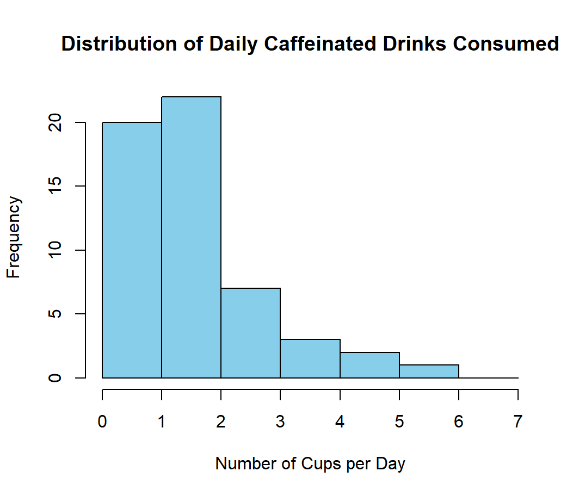
The histogram for daily caffeinated drinks is right-skewed. This means most students drink only 1–2 cups per day, but a few students drink a very high amount.
In terms of shape, the distribution has a long tail on the right side.
For spread, the number of cups ranges from 1 to 6, showing moderate variation.
For averages, the mode and median are both 2 cups, which represents the typical daily consumption of students.

Numerical Data Visualization:
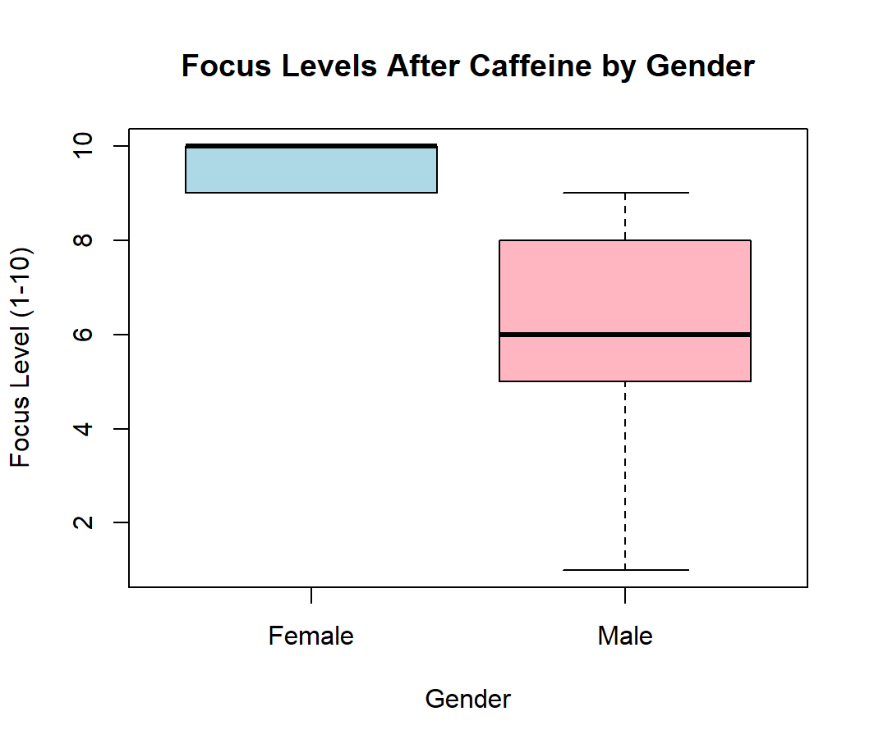
The boxplot compares focus levels by gender.
In terms of shape and spread, both genders have a similar distribution with no obvious outliers.
For averages, the median focus level for both males and females is around 7 out of 10, meaning caffeine improves focus consistently across genders.

**The female group shows a very compact box plot with almost no spread, due to the small sample size (n=9) and the highly concentrated focus scores, which are all between 7 and 9 out of 10. This indicates that the small female sample had consistently high focus levels after consuming caffeine, with little variation. **

Measures of Central Tendency:

Variable | Mean | Median | Mode
Focus Score (1–10) | 6.73 | 7 | 8
Cups per Day | 2.05 | 2 | 2
Effect Duration (Hours) | 3.23 | 3 | 2
Sleep Impact Score (1–5) | 2.85 | 3 | 3

Mean, median, and mode were calculated for each numerical variable. The mean focus score was 6.73 (median=7, mode=8), indicating most students rated focus levels moderately high. Daily cups of caffeine had a mean of 2.05, with median and mode both at 2, matching the histogram peak. Effect duration averaged 3.23 hours (median=3, mode=2), and sleep impact scores centered around 3 (mean=2.85, median=3, mode=3), showing neutral perceptions overall.

Measures of Dispersion:

Variable | Range | Standard Deviation
Focus Score (1–10) | 9 | 2.12
Cups per Day | 5 | 1.01
Effect Duration (Hours) | 8 | 1.98
Sleep Impact Score (1–5) | 4 | 1.14

Range and standard deviation were calculated to assess data spread. Focus scores had moderate variability (range=9, SD=2.12). Daily caffeine consumption showed low variation (range=5, SD=1.01), with most students drinking 1–2 cups. Effect duration had moderate spread (range=8, SD=1.98), while sleep impact scores were relatively consistent (range=4, SD=1.14), clustered near the neutral midpoint.

Conclusion

Summary of Findings:
In summary, our descriptive analysis reveals that caffeine consumption is a prevalent habit among the surveyed UTM student population, with 74.3% of respondents reporting regular intake. The data shows that Coffee-based drinks are the most popular choice at 47.3%, followed by tea. While students reported a median focus level of 7 out of 10 after consumption, the right-skewed distribution of daily cups indicates that while most drink 1–2 cups, a minority consumes significantly higher amounts. All statistical analyses and visualizations were performed using R programming to ensure data accuracy

Learning Reflections:
By conducting this healthcare-focused study, our group learned the importance of systematic data collection and the complexity of student lifestyle habits. Mathematically, we learned how to differentiate between categorical and numerical variables for statistical validity. Technologically, the use of R programming taught us how to transform raw data into professional visual distributions, allowing for a clearer understanding of population trends.

References
UTM Faculty of Computing (2025). SCST1223 Probability and Statistical Data Analysis Project Guidelines.
significantly greater sleep fragmentation occurred when 400 mg was consumed within 8 hours of bedtime (p < .05). Additionally, perceived sleep quality was significantly reduced when 400 mg was consumed 4 hours prior to bedtime (−34.02%, p = .006) but not at 8 or 12 hours.
ConclusionsAbstract
Study Objectives
To investigate the effect of a typical dose of caffeine and a high dose of caffeine consumed in the morning, afternoon, and evening on subsequent sleep.
Methods
Using a placebo-controlled, double-blind, randomized crossover design, 23 males (25.3 ± 5.0 years) with a moderate habitual caffeine intake (<300 mg∙day⁻¹) completed seven conditions: placebo, and 100 and 400 mg of caffeine consumed 12, 8, and 4 hours prior to bedtime, with a 48-hour washout. In-home partial polysomnography and sleep diaries were used to assess sleep. Linear mixed models estimated the effect of each condition.

Results
No significant effect on objective or subjective sleep occurred with the 100 mg dose of caffeine compared with the placebo (p > .05), but significant effects occurred with the 400 mg dose (p < .05). Significant delays in sleep initiation and alterations to sleep architecture were observed when 400 mg was consumed within 12 hours of bedtime (p < .05), and
A 100 mg dose of caffeine can be consumed up to 4 hours prior to bedtime, but 400 mg may negatively impact sleep when consumed as one dose within 12 hours of bedtime, with the adverse influence on sleep increasing the closer consumption occurs to bedtime. The discrepancy between objective and subjective sleep quality suggests that individuals may have difficulty accurately perceiving the influence of caffeine on sleep quality.
Resource: oxford acadimic

Appendix
Variable:
https://docs.google.com/forms/d/1VVs7lpNnCssQnbjkp3SGMHyO4q5_Tt8UlS8DpYPv_vw/edit#responses

Instructions

📝 Group 6: Project Phase 1 – Live Work Distribution
Overall Lead/Quality Control: Mohammed Alsakkaf
Check for consistency across the entire Doc and ensure R-results match the tables.

🟢 Task 1: The Context & Variables (Sections 1 & 2)
Assign to Member A: [Insert Name]
- Mission: Complete the "Introduction" and "Data Collection" write-up.
- Specifics:
  - Section 1.1-1.3: Background on caffeine, the problem of sleep in students, and the scope (UTM JB).
  - Section 2.1-2.2: Describe our 60+ sample size and convenience sampling.
  - Section 2.3: Fill in our finalized Top 7 Variable Table (Measurement levels must match our proposal).

- Need help ? go here

🔵 Task 2: The Graphics Specialist (Section 3 - R-Graphs)
Assign to Member B: [Insert Name]
- Mission: Generate the visual side of the data from the CSV file.
- Specifics:
  - Generate a Pie Chart for "Drink Preference" and a Bar Chart for "Year of Study/Faculty."
  - Generate a Histogram for "Cups per Day" (Write 1-2 sentences on Skewness/Shape—This is vital for marks!).
  - Generate a Boxplot for "Focus level by Gender."
  - Paste these images into Sections 3.1.1 and 3.2.1-3.2.2.

- Need help ? go here

🟠 Task 3: The Statistician (Section 3 - R-Tables)
Assign to Member C: [Insert Name]
- Mission: Generate the numerical summaries and fill in all the data tables.
- Specifics:
  - Section 3.1.2: Generate frequency and percentage tables for categorical data.
  - Section 3.2.3: Calculate Mean, Median, and Mode for all quantitative columns.
  - Section 3.2.4: Calculate Range and Standard Deviation.
  - Input all these numbers into the tables in the Google Doc.

- Need help ? go here

🟣 Task 4: Conclusion, References & Appendix (Sections 4, 5 & 6)
Assign to Member D: [Insert Name]
- Mission: Finalize the report’s impact and proof-of-work.
- Specifics:
  - Section 4.1: Write the one-paragraph Summary of Findings based on Member B & C's results.
  - Section 4.2: Finalize the Learning Reflections section.
  - Section 6.0: Collect screenshots of the Google Form and paste the FULL R-script into the Appendix.
  - Last Check: Cross-reference all Page Numbers in the Table of Contents.

- Need help ? go here

💡 Rules for working on the Google Doc:
- Do not delete the placeholders (the text in brackets like [INSERT TABLE HERE]) until your data is ready to paste there.
- R-Users (B & C): Run your code in R-Studio, then copy the result/table over to the Google Doc once it's final.
- Use the "Comments" feature: If you are unsure about a section, leave a comment for the Team Lead instead of leaving it blank.

💡 Help Guide for Team Members

🌟 Member A (Sections 1 and 2)
Your job is to write the first part of the report. Follow these simple steps:

Step 1: Introduction (Sections 1.1 - 1.3)
Just write 2 or 3 short paragraphs explaining these 3 things:
- The Idea: Many UTM students drink coffee or energy drinks to stay awake and study. We want to see if this is bad for their health and their sleep.
- The Problem: Students might be too "addicted" to caffeine. They drink it to focus, but then they cannot sleep at night. This is a "Healthcare" problem.
- The Goal: We want to know how many cups they drink and if it helps them focus or just ruins their sleep.

Step 2: How we got the data (Sections 2.1 - 2.2)
You need to explain where our numbers came from:
- Who did we ask? We asked students from different faculties in UTM (Computing, Science, Engineering, etc.).
- How many? We have at least 60 students (very important!).
- The Method: We made a Google Form and sent the link on WhatsApp and Telegram groups.

Step 3: The Variable Table (Section 2.3)
You must fill in the table with these 7 main things we are measuring:
- Gender/Faculty: (Nominal) - Is the student male or female? Which faculty?
- Caffeine Choice: (Nominal) - What do they drink? (Coffee, Tea, or Soda).
- Sleep Impact Score: (Ordinal) - A 1 to 5 scale (Bad to Good sleep).
- Addiction Level: (Ordinal) - Do they need caffeine "Always" or "Rarely"?
- Focus Levels: (Interval) - A 1 to 10 scale (How awake do they feel?).
- Effect Duration: (Ratio) - How many hours does it last? (Like 4 hours).
- Cups per Day: (Ratio) - How many drinks today? (Like 2 cups).

💡 Final Advice for Member A:
- Use simple English. Don't make it complicated.
- Always mention the number 60 so the teacher knows we did the work.
- Make sure you link to "Health" (like sleep or energy).

🌟 Member B (R Graphs & Visuals)
Your job is to take our CSV data, put it into R-Studio, and make 4 main charts. After you put the charts in the report, write 2 simple sentences under each one.

Step 1: Categorical Graphs (Section 3.1.1)
- What to do: Make two charts about things people choose (not numbers).
- Graph 1 (Pie Chart): Show what students like to drink (Coffee vs Tea vs Energy Drinks).
  - In the report, write: "This circle chart shows that Coffee is the most popular choice among UTM students."

- Graph 2 (Bar Chart): Show which Year or Faculty our students are from.
  - In the report, write: "This bar chart shows that most students we asked are from the [name of faculty]."

Step 2: Histogram - Numbers (Section 3.2.1)
- What to do: Make a Histogram for "Cups per Day."
- Very Important: You must look at the "Shape."
  - If most bars are on the left and get smaller on the right, write: "The graph is Right-Skewed."
  - Explain: "This means most students only drink 1-2 cups, but a few students drink a lot (more than 5)."

Step 3: Boxplot - Comparison (Section 3.2.2)
- What to do: Make a Boxplot to compare two things.
- Idea: Compare "Focus Level" for Male students vs Female students.
- What to look for: Look for "Outliers" (little dots alone outside the chart).
  - In the report, write: "The boxplot shows that both genders have similar focus levels after drinking caffeine. There are no extreme outliers."

💡 Final Advice for Member B:
- Don't forget the labels: Make sure every graph has a clear title (like "Figure 1: Preferred Caffeine Source") and names on the X and Y axes.
- The Skewness: If you forget to mention "Skewness" (Right-Skewed, Left-Skewed, or Symmetric) for the histogram, the team will lose marks!
- Colors: Use colors like light blue or green so the charts look clean and professional in the report.

🌟 Member C (Calculating Numbers)
Your job is the "Math." You need to run simple commands in R to find the averages and totals. Then, type those numbers into the tables in our Google Doc.

Step 1: Categorical Data (Sections 3.1.2 - 3.1.3)
You need to find the "Counts" and "Percentages."
- What to do: In R, count how many people chose each option (Example: how many said "Coffee"?).
- What to fill in:
Sample Size (
nnn
  - ): The number of people (Example: 20 students).
  - Percentage (%): The part out of 100 (Example: 33%).

- Important Check: When you add up all your percentages, the total must be exactly 100%.

Step 2: Measures of Central Tendency (Section 3.2.3)
You need to find the "Middle" of the data for things like Focus Levels and Cups per Day. Use these 3 commands in R:
- Mean: This is the Average. (R command: mean)
- Median: This is the middle number. (R command: median)
- Mode: This is the answer that appears the most times.
- What to do: Type these numbers into the table on Page 6 of our report.

Step 3: Measures of Dispersion (Section 3.2.4)
This shows how "spread out" our numbers are.
- Range: Find the Highest number minus the Lowest number (Example: 8 hours - 1 hour = Range of 7).
- Standard Deviation (SD): This shows if everyone is the same or if they are all very different. (R command: sd)
- What to do: Just write the result for Range and SD in the short text area in Section 3.2.4.
💡 Final Advice for Member C:
- Work with Member B: Make sure the numbers in your tables match the bars and slices in Member B's graphs! (If the table says 10% and the graph shows 50%, the teacher will notice).
- Zero values: If a student answered "0" for something, make sure you include it in the average.
- Decimals: Use 2 decimal places (like 4.56 or 1.20) to make the math look professional

🌟Member D (Ending & Appendix)
Your job is the "Cleanup" and the "Ending." You need to wait until Members B and C finish their parts so you can summarize the results.

Step 1: Summary of Findings (Section 4.1)
- What to do: Read the results from the graphs and tables. Then, write one short paragraph about what we learned.
- Example phrases to use:
  - "In summary, we found that most UTM students drink 1-2 cups of coffee per day."
  - "The data shows that caffeine helps students focus, but many students still struggle with sleep."
  - "Most of our survey respondents came from the [Name] Faculty."

Step 2: Learning Reflections (Section 4.2)
- What to do: Write about what we learned during the project. Keep it simple:
  - The Math: We learned how to categorize data into "Nominal" and "Ratio."
  - The Tech: We learned how to use R Programming to make fast charts instead of doing it by hand.

Step 3: Appendix A – The Survey Proof
- What to do: Go to our Google Form. Take a screenshot of the "Questions" tab.
- Where: Paste those pictures in Section 6.0 (Appendix A). This shows the teacher the actual questions we asked.

Step 4: Appendix B – The R Code
- What to do: Ask Members B and C for their R-Studio Script (the text code they typed).
- Important Tip: Paste the code into Section 6.0 (Appendix B). Use a font that looks like code (like Courier New) so it looks very professional.

💡 Final Advice for Member D:
- Table of Contents: This is your final task. Check every page in the report and make sure the page numbers in the "Table of Contents" match the real page numbers!
- The Look: Check the document for big empty white spaces or weird formatting. Make sure it looks like a clean, finished book.
- Convert to PDF: When everything is perfect, save the file as a PDF before the Lead (Mohammed) submits it.

